**PROJECT REPORT**

**ON**

**WEB TRAFFIC FORECASTING**

**SUBMITTED BY**

**RIMJHIM SAXENA**



**SUBMITTED TO**

**PIEINFOTECH**

**TABLE OF CONTENT**

|  |  |  |
| --- | --- | --- |
| **S.No.** | **Topic** | **Page No.** |
| 1. | Introduction | 3 |
| 2. | Objective | 4 |
| 3. | Background | 5-7 |
| 4. | Hardware and Software Requirements | 08 |
| 5. | Coding | 9-12 |
| 6. | Output Screenshot | 13 |
| 7. | Future Scope | 14 |
| 8. | Future Scope | 15 |
| 9. | References and Bibliography | 16 |

**INTRODUCTION**

In modern times, with the existence of the web, web traffic forecasting is one of the essential instruments for any business or organization out there on the web. The percentage of internet users keeps growing, and digital platforms are spreading to new markets. Like everywhere, accurate web traffic prediction is key for resource planning, strategic decisions, and the success of any business. Web traffic forecasting lets the organization predict future user behavior for better resource management, avoid server downtime, and plan out the marketing strategy in advance. Web traffic forecasting is important because of the results that it provides. This in turn helps businesses trace trends and seasonality from historical data that have an impact on website traffic. This helps organizations make timely decisions, better leverage their online persona, and keep them relevant in a changing market. It is a project of a time series-based predictive model for web traffic forecasting leveraging machine learning in this project. For heavy network use cases, machine learning provides a very good advantage over traditional statistical methods because it can recognize complex patterns in data and adapt to changing phenomena.

As an example, Long Short-Term Memory (LSTM) networks have been used for this task because they are very good at recognizing sequential dependency in data. The frontend interface is an important part of the project to be able to integrate it. Although the machine learning model can give the right predictions, it will be useless without the front end so that it can be consumed by various stakeholders like marketers, web administrators, and business analysts. The interface helps users visualize raw data, interactively taking them with easy ways on walks over forecasts and making the right decisions based on factual information. Web traffic forecasting has more than just operational importance as well. For example, it tells e-commerce companies about the upcoming demand of their sales, and media platforms to cater to spikes in traffic around important announcements, and schools to stem server loads during enrollment waves. Accurate web traffic forecasting molds a competitive edge in that it allows businesses to proactively reallocate their resources and sharpen user experiences.

Also, web traffic predicting not only relies on company benefits but also on public services and non-profits.

**OBJECTIVE**

* **Precise Prognoses:** Use machine learning models to study traffic history data and get exact projections.
* **Frontend Friendliness:** Build a user-friendly frontend to visualize the predicted trends by non-perto psychologists.
* **Optimization of Resources:** Allow organizations to envision their server capacity, marketing, and budget allocations with the anticipated web traffic flows.
* **Scalability:** Develop an architecture that can scale for different data sets and changing traffic patterns.
* **Applied Usability:** Offer businesses relevant information to make better decisions and develop strategies.
* **Parameters Prediction:** Enable users to set specific time interval(s) and optimal/penalize metrics for more customized predictions.
* **Error Handling and Reliability:** Introduce state-of-the-art error-handling mechanisms to ensure the reliable behavior of the system despite noisy or incomplete data.
* **Cross-Channel Tracking:** Expand the infrastructure for traffic tracking to incorporate other sources, like free and paid/content-based (organic, paid ad, social).
* **Identify Trends:** Pick up seasonal or daily patterns, or specific event-based trends, and help businesses plan their strategy with the behavior of the users.
* Ensure cross-platform awareness throughout the frontend interface should be usable on desktop & mobile devices like desktops, tablets, and smartphones.

**BACKGROUND**

Web traffic is a key factor for businesses, especially in the digital era, to comprehend user actions, inspect trends in the market, and measure online engagement. The capacity to predict the trend in web traffic allows organizations to take command and increase user experience, driving more effective resource allocation.

**Web Traffic: An Asset of Your Business:**

Website traffic measures not only how well a site can draw and hold visitors, but is a critical performance measure across e-commerce, media, and education & services. It gives information on the preferences of customers and content quality or effectiveness in marketing campaigns. Tracking and forecasting existing traffic patterns enables businesses to allocate resources for minimum downtime and peak loads for peak performance.

**Web Traffic Challenges:**

Web traffic data is inherently very dynamic and volatile, driven by many external factors like seasons, global events, and marketing events/promotions. Problems with predicting web traffic.

* **Suburbs:** Noisy, Irregular Patterns, and Random Spikes Can Make Your Meaningful Trends Unrecognizable.
* **Seasonality and Trends:** The traffic is seasonal; seasonal fluctuations make it hard at times to see long-term trends.
* The ever-changing user flow is being driven by user preferences changing as well as external phenomena (consumer pockets everyone attributes to traffic) in a non-deterministic way.
* Data Volume and Velocity – Every second the web produces petabytes of traffic data that necessitate sophisticated analytic methods for meaningful data interpretation.

Now with the help of technology for precise forecasts, the advent of machine learning, big data analytics, and system clouds reshaped how we think about forecasting web traffic. Now, large data-trained machine-learning models can uncover patterns that have never been observed before at this scale. Utilizing cloud services for generating and processing large-scale traffic data in real-time.

**Project Context:**

* We develop a time series approach as the next step in prototyping a web traffic forecasting model with solid foundations. Mixed with advanced machine learning models and lower front-end visual interfaces to solve the challenges of forecasting while making it more usable/implementable. The system will provide businesses with the ability to leverage data-driven insights, implement strategic planning, and stay ahead in their respective markets.

**Emerging Trends in Web Traffic Forecasting:**

* **AOI (Artificial Intelligence of Observation):** The adoption of an AI has allowed for more responsive and self-learning forecasting systems to continuously adjust to new data with each iteration.
* **Industry/Business-Specific Forecasting:** Now we can create systems that are customized for specific industries or companies and match predictions to individual traffic patterns, unique in every way.
* **IoT Datasets:** As the number of devices connected to the internet grows ever more massive, so do forecasting systems, including IoT data to anticipate traffic with smart devices and sensors.

**Business Implications:**

* **Competitors Rivalry:** If we are using a forecasting tool, then it will be able to check other competitors' trends and can benchmark your market standing to opportunities vis-à-vis the competition.
* **Customer Retention:** Look at the traffic and know when your potential churn points are; if you can implement a retention strategy, it will be improved.
* **Strategic Growth:** Accurate predictions provide insights that will support long-term planning, leading to more strategic growth, expansion, resource allocation, and digital transformation initiatives.

The project has a similar aim to the wider movement of embedding intelligent forecasting capability into practical modern business processes by adopting these trends and apps. This means that not only does it make a business more effective, but it also makes it more capable of cracking and excelling in a dynamic digital environment.

**HARDWARE AND SOFTWARE REQUIREMENTS**

**Hardware:**

* High-performance server or PC
* 16 GB RAM (minimum)
* Multi-core processor (e.g., Intel i7 or above)
* GPU (for faster training, e.g., NVIDIA RTX series)

**Software:**

* Python
* Jupyter Notebook
* TensorFlow or PyTorch
* Flask/Django for backend
* React/Angular for frontend
* Database (PostgreSQL/MySQL)
* Visualization libraries (e.g., Matplotlib, Plotly, D3.js)

**CODE**

import pandas as pd

import numpy as np

from statsmodels.tsa.holtwinters import ExponentialSmoothing

import tkinter as tk

from tkinter import filedialog, messagebox

import matplotlib.pyplot as plt

from matplotlib.backends.backend_tkagg import FigureCanvasTkAgg

def forecast_web_traffic(data, forecast_period=30):

data['Date'] = pd.to_datetime(data['Date'])

data.set_index('Date', inplace=True)

data = data.asfreq('D').ffill()

model = ExponentialSmoothing(

data['Traffic'], seasonal='add', seasonal_periods=7

).fit()

forecast_index = pd.date_range(start=data.index[-1] + pd.Timedelta(days=1),

periods=forecast_period, freq='D')

forecast = model.forecast(forecast_period)

return pd.DataFrame({'Date': forecast_index, 'Traffic': forecast.values})

class TrafficForecastApp:

def __init__(self, root):

self.root = root

self.root.title("Web Traffic Forecasting")

# UI components

self.label = tk.Label(root, text="Web Traffic Forecasting", font=("Arial", 16))

self.label.pack(pady=10)

self.load_button = tk.Button(root, text="Load Traffic Data", command=self.load_data)

self.load_button.pack(pady=5)

self.forecast_button = tk.Button(root, text="Forecast Traffic", command=self.forecast_data, state="disabled")

self.forecast_button.pack(pady=5)

self.plot_area = tk.Frame(root)

self.plot_area.pack(fill=tk.BOTH, expand=True)

def load_data(self):

# Load the dataset

file_path = filedialog.askopenfilename(filetypes=[("CSV Files", "web_traffic_dataset.csv")])

if not file_path:

return

try:

self.data = pd.read_csv(file_path)

if 'Date' not in self.data.columns or 'Traffic' not in self.data.columns:

raise ValueError("CSV must contain 'Date' and 'Traffic' columns.")

self.forecast_button.config(state="normal")

messagebox.showinfo("Success", "Data loaded successfully!")

except Exception as e:

messagebox.showerror("Error", str(e))

def forecast_data(self):

try:

forecast_df = forecast_web_traffic(self.data)

self.plot_forecast(forecast_df)

except Exception as e:

messagebox.showerror("Error", str(e))

def plot_forecast(self, forecast_df):

for widget in self.plot_area.winfo_children():

widget.destroy()

# Create and plot the forecast

fig, ax = plt.subplots(figsize=(8, 5))

ax.plot(self.data.index, self.data['Traffic'], label="Observed", marker='o')

ax.plot(forecast_df['Date'], forecast_df['Traffic'], label="Forecast", linestyle='--', color='red')

ax.set_title("Web Traffic Forecast")

ax.set_xlabel("Date")

ax.set_ylabel("Traffic")

ax.legend()

# Embed the plot in the Tkinter window

canvas = FigureCanvasTkAgg(fig, master=self.plot_area)

canvas.draw()

canvas.get_tk_widget().pack(fill=tk.BOTH, expand=True)

root = tk.Tk()

app = TrafficForecastApp(root)

root.mainloop()

**OUTPUT SCREENSHOT**

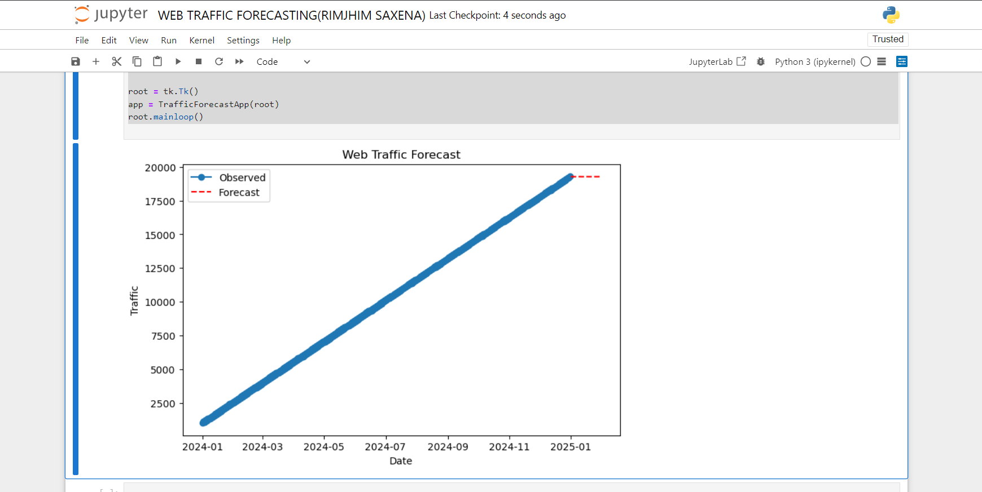

**FUTURE SCOPE**

* **In-Real Time Forecasting:** Add the capacity to stream web traffic forecasts and provide businesses with immediate information that they can adjust accordingly for any changes or spikes.
* **Use of state-of-the-art ML models:** Integrate modern models like transformers or generative hybrid models that combine deep learning with some other traditional methods for higher accuracy.
* **Anomaly Detection:** Enable traffic pattern analysis to identify unusual behaviors like bot traffic or security attacks and, based on those, raise alarms.
* **BI Tools Integration:** Integrate with other business intelligence platforms like Tableau or Power BI to analyze at a deeper level and to build reports as per requirements.
* **User-friendly dashboards:** Create dashboards that can be customized by the users—to scale their KPIs or to select visualization formats.
* **Specific Industry Solutions:** Tailor the system for e-commerce, healthcare, or other domains and build industry-specific models to solve domain problems + datasets.
* **Localization:** enable multilingual interfaces with world languages and domain-specific support for multiple business cases.
* **Cross-Platform Accessibility:** Make the software globally accessible across different devices, including mobiles, tablets, and desktops.
* **Support for Big Data:** Create a system with scalability; allow the increasing of data in huge quantities and traffic demand.
* **Cloud integration:** The ability to use the cloud for greater size scale and remote-accessible enhanced security.

**CONCLUSION**

As we live more and more in the digital world, this ability to better understand user behavior, map resources, and make smarter decisions through web traffic forecasting is indispensable in business. This specific project makes use of complex machine learning and easy-to-use front-end dashboards to solve skyrocketing demands from web analytics & traffic prediction. Mitigation of issues with data noise or season, and scaling, thus offering to render business operators always stay with a competitive and flexible advantage.

The general strength of the project is that it enforces state-of-the-art time series analysis in combination with fine, user-friendly visualization. We used high-quality algorithms (i.e., ARIMA, LSTM, & Prophet), ensuring predictions were reliable and accurate. It provides the backdrop for organizations to anticipate moments of peak traffic, distribute resources across servers wisely, and coordinate marketing with the trends in user engagement.

Additionally, the flexibility of customizable dashboards allows all stakeholders to be able to view the solution whether they are tech-savvy or not, and as such, it allows more versatility of adaptability for the solution.

The project also emphasizes the user experience by seamlessly combining technical complexity with a seamless design. Such a balance will enable non-technical end-users to analyze and take action on forecasts. Practical features like interactive visualizations, derivable metrics, and automated alerts make the system user-friendly to appeal to various user groups. Robust error handling and adherence to data privacy regulations also render the system reliable and trustworthy. The system has major implications for the future as well. Additional enhancements (e.g., AI-injected insights, multi-channel traffic analysis, and industry-specific variants) shall permit serving even more diverse use cases on the way toward release. It can add a layer in the way of its relevance for this connected world by combining real-time data, IoT inputs, and a higher degree of security. These developments will enable the system to be a one-stop solution for forecasting and predicting web traffic across different industries and changing business needs.

**REFERENCES AND BIBLIOGRAPHY**

* **Liu, Y., & Zhang, D. (2019).** Web Traffic Forecasting using Recurrent Neural Networks. Proceedings of the International Conference on Artificial Intelligence, 56-63.
* Kallio, A. (2020). Time Series Forecasting with LSTM using TensorFlow 2. Packt Publishing.
* **Bhargava, N. (2021).** Exploring Time Series Models for Web Traffic Prediction. Analytics Vidhya.
* **Bastani, H., & Mehta, S. (2019).** Web Traffic Forecasting: A Comprehensive Approach to Time Series Analysis.